Build A Mobile App

|  |  |
| --- | --- |
| Team ID | PNT2022TMID45278 |
| Project Name | Real-time river water quality monitoring and control system |

Design Your UI To Display The Water Turbidity, PH Values

LogIn Page

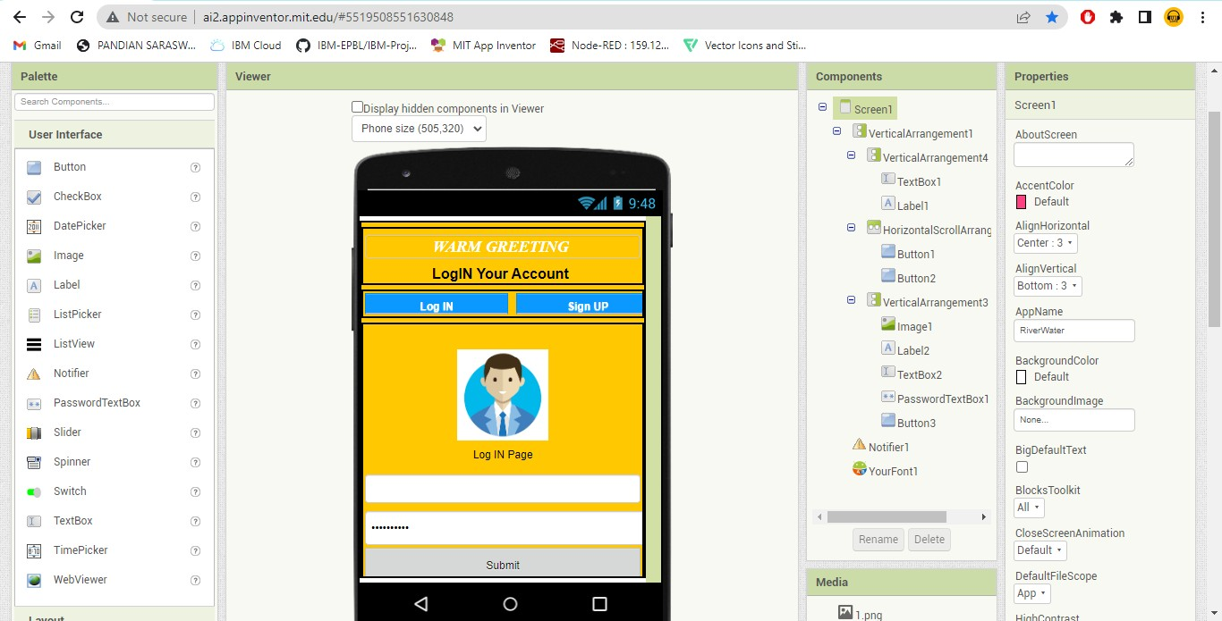

SignUp Page

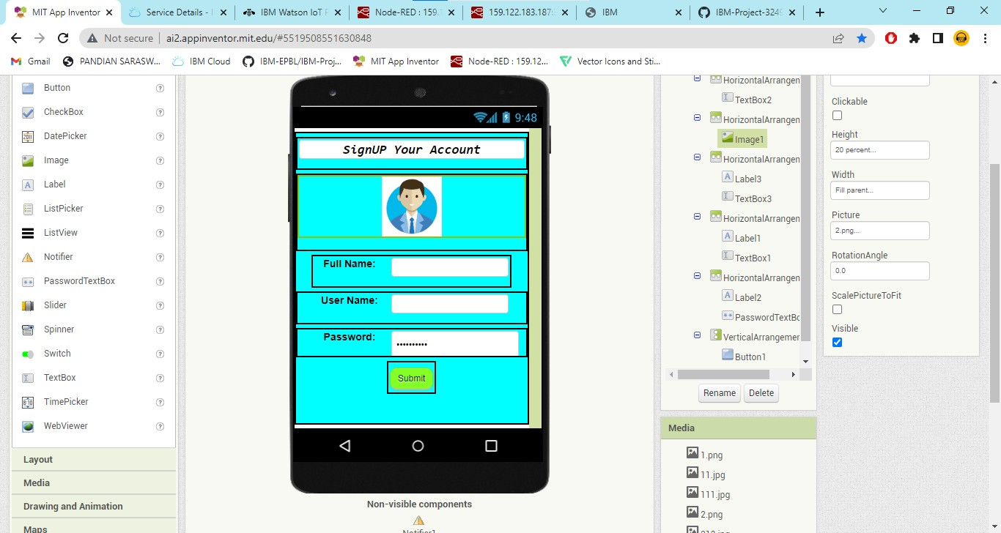

Monitoring Window

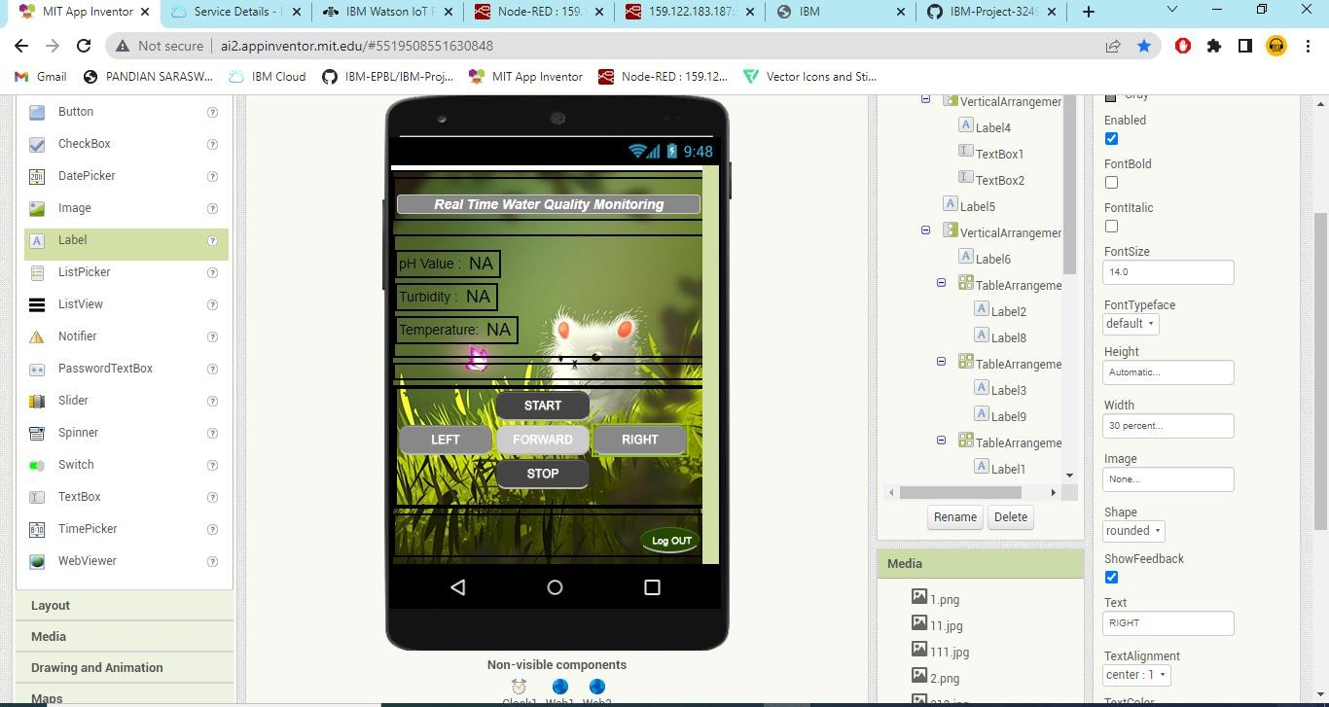

Mobile version

